Day 67: Asynchronous Set and Reset D Flip-Flop

Introduction: An Asynchronous D Flip-Flop with Set and Reset is a sequential circuit used to store one bit of data. The Set input immediately makes the output Q HIGH, while the Reset input immediately makes Q LOW without waiting for the clock signal. During normal operation, the D input is stored at the rising edge of the clock. In this project, asynchronous Set and Reset D Flip-Flops are designed using Verilog HDL and simulated using Xilinx Vivado.

With Asynchronous Set

Design:

Testbench:

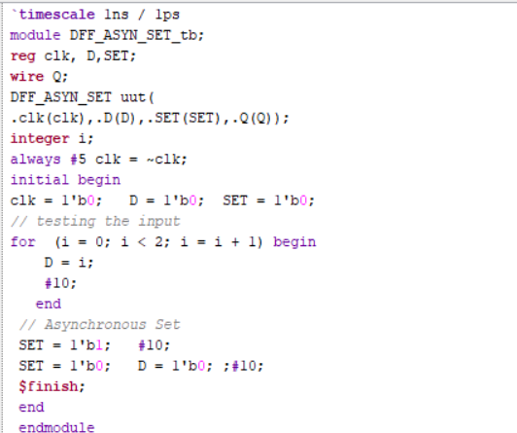

Waveform:

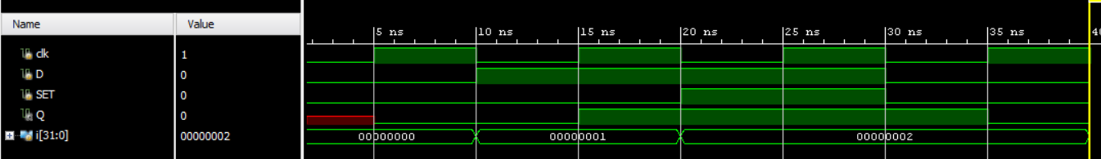

Schematic:

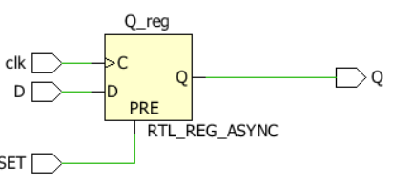

With Asynchronous Reset

Design:

Testbench:

Waveform:

Schematic:

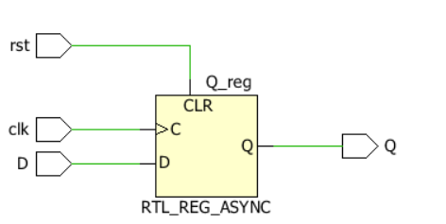

With Asynchronous Set and Reset

Design:

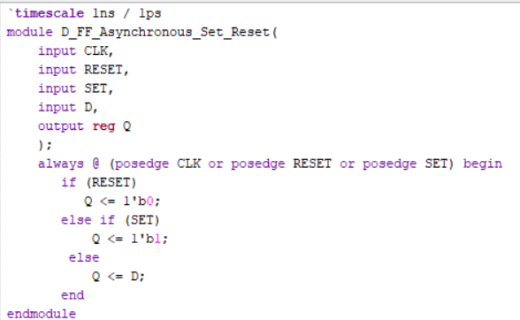

Testbench:

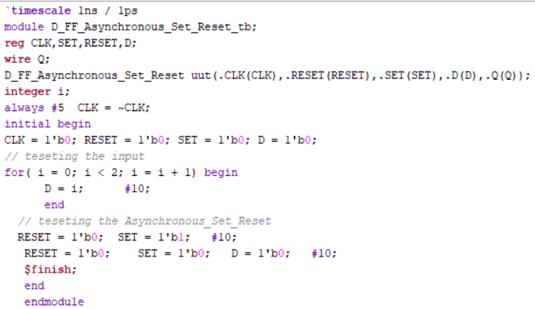

Waveform:

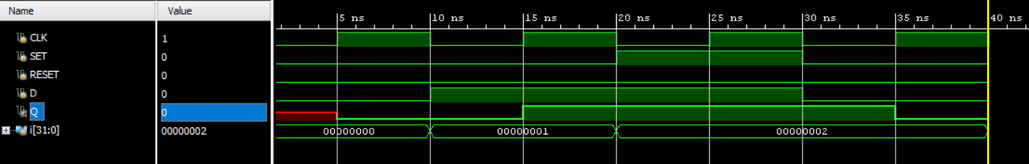

Schematic:

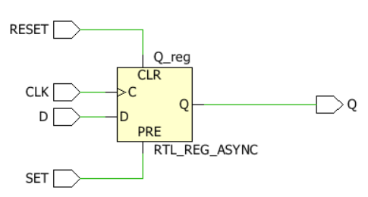

Observation: The D Flip-Flop with Asynchronous Set, Reset, and combined Set and Reset was implemented and verified through simulation in Xilinx Vivado. The Set input immediately makes Q HIGH, while the Reset input immediately makes Q LOW without waiting for the clock signal. During normal operation, the output follows the D input at the rising edge of the clock. The simulation waveforms were observed to verify the functionality of all designs.

#PHANEENDRA.SINGUDASU

